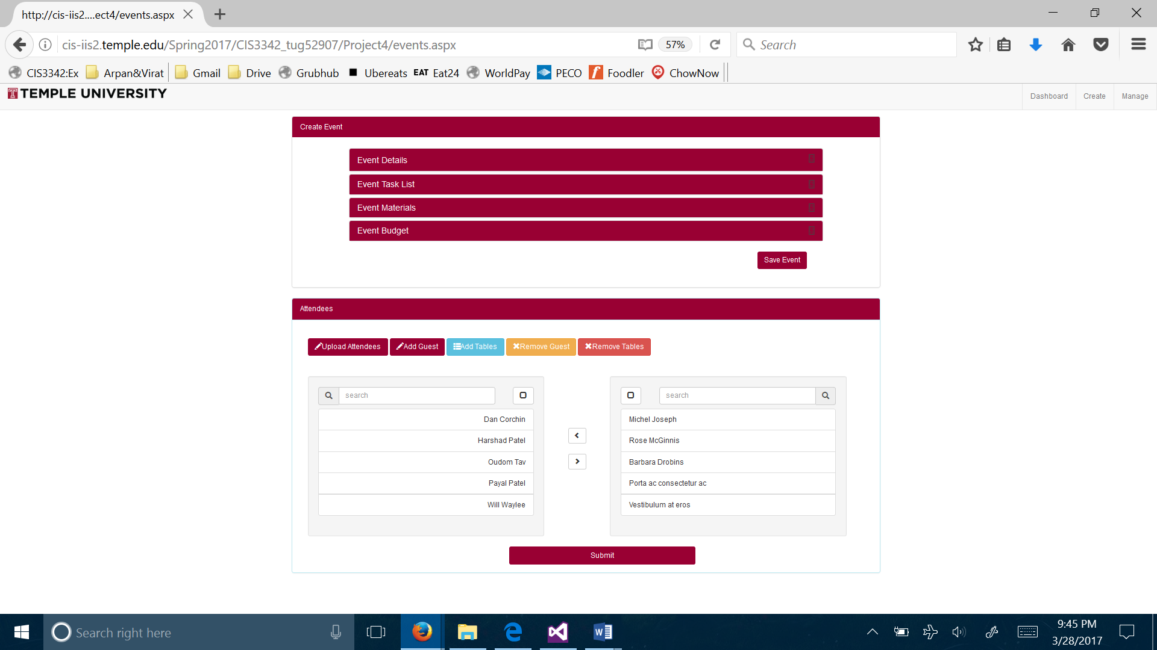

A administrator can upload attendees excel file to upload. On the left table will have all attendees first and last name and from there a admin can move names to the right where it will have multiple tables which attendees should be on which table. Attendees and tables can be added or remove manually.